Bringing Light to Feelings
The Psychological Effect of Color When Applied to Environmental Lighting

Jennifer Huff
The Guildhall at SMU
Plano, Texas

Matthew Streit
The Guildhall at SMU
Plano, Texas

Abstract- There is a language to color, though it is unspoken. This thesis is a study of that language and what can be defined as emotionally common associations. There have been many studies over the years on how color affects people emotionally, be it in a work environment, in someone’s home, or in a psychological study. Few have tested the effects of color in an immersive environment, such as lighting in Video Games. This study had people exploring a neutrally created environment with the lighting being the only thing altered for color. This allowed us to see how the changes made to the color of lighting affected them emotionally and psychologically.

INTRODUCTION
It is generally accepted within fine art that color can affect a person emotionally [1]. However, there is an ongoing debate as to how colors are interpreted and how they affect people [2]. This debate normally involves content on a canvas. However, one area that has not yet been investigated is how environmental lighting in a game and walking into a virtual room of colored light effects a person emotionally.
Color theory, a collection of guidance to color mixing and the visual effects of specific colors and color combinations [3], has always been applied to fine art, be it paintings on a wall or color in a house. This touches closely to environmental effects; does a blue or green wall calm a person down? For some, Blue has been seen to both depress and relax a person along with making them feel cold despite turning up the temperature in the room. For others, red has been seen to raise anxiety levels but increase workflow. This is color theory when applied in an artistic way. When attempting to apply these theories there is a knowledge gap between the existing static applications and the possible immersive applications in games.
The expectation of this study is that similar effects will be found when lighting is changed as when colors are changed in a painting. Participants went through an environment, created with neutrality in mind as to lay out and lighting, with only the lighting being changed. Participants indicated their emotional reaction to the environment they experienced to see if there was a consistently different reaction due to the color.

RESEARCH AND REVIEW

A. Color Theory
Color theory is a collection of guidance on how to mix colors together [4], whether to make a secondary color (e.g., mixing red and yellow to get orange) or which colors next to each other are considered ideal. A commonly used tool for color mixing is the color wheel, as seen in fig. 1. This tool guides a person on how to achieve the color they desire in their artwork across all mediums.

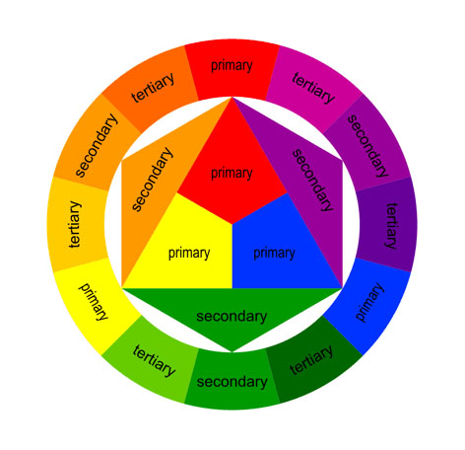

Fig. 1. Color wheel [5].

While the color wheel serves its purpose on how to mix colors it also demonstrates how to mix colors with colors schemes as seen in fig. 2. To achieve a more cohesive feeling or to emphasize another color one can use the color wheel as a tool for guidance.
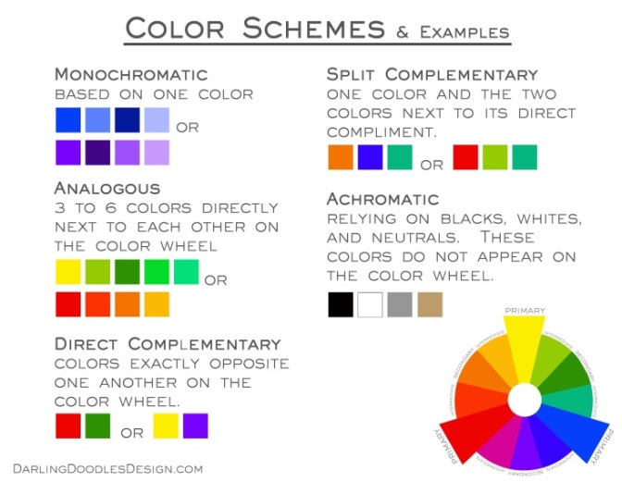

Fig. 2. Color Schemes [6].B. Color Psychology
Color psychology is commonly defined as the study of color and its effects on human emotions. According to Birren [1], there are universal reactions to color. Studies show blue and yellow have a subliminal effect on people causing them to feel tiresome in their work environment. In contrast, the same observations showed a blue-green or peach color encouraged people to feel comfortable. Every color can rouse an emotional response, though knowing the unspoken language is a key factor in being able to use it constructively [2].
According to Rachel Gillet, “The implications of color’s effect on people’s emotions are far reaching” [7], the colors used in marketing has some in-depth meaning, which is a primary example of color psychology in use. Color psychology can be used in many ways as seen in fig. 3. For more than just marketing, it can be tied to emotions, religions and politics.
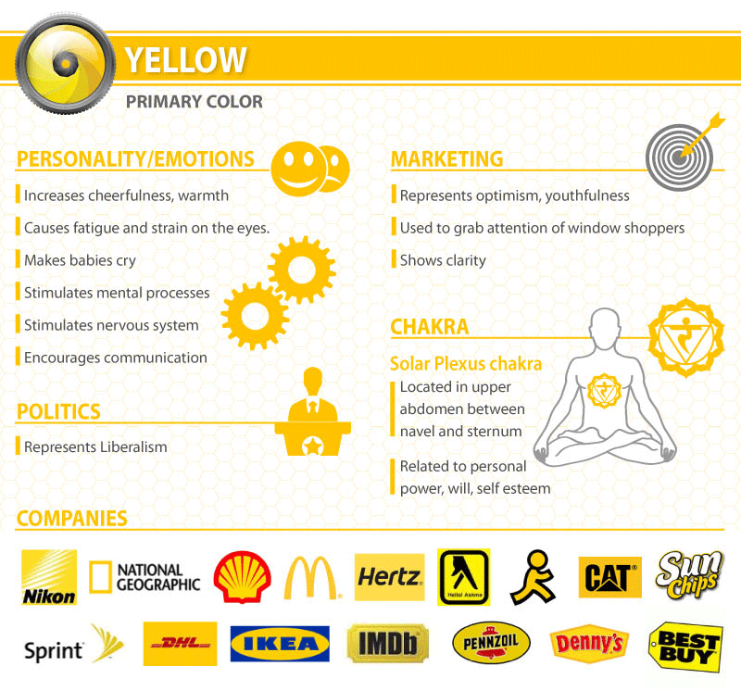
Fig. 3. Colors and relationships, yellow [7].

Many of these colors speak subconsciously to people, though studies have gathered a number of associations commonly attributed to individual colors. Table I. shows a number of the more common associations from [1 - 3].
Table I. COLORS AND THEIR EMOTIONAL ASSOCIATIONS

Color | Associations
Red | Danger, anger, rage, hate, war, blood, excitement, tension, power, health, vigor, warmth, friendship, love
Orange | Wholesomeness, wisdom, justice, warm, intimate, joy, ambition, happy, cheerful, lively, exciting, passive, mellow, energetic
Yellow | Neutral, safety, cheerful, joy, caution, celestial, health, intelligence, coward, deceit, treachery, active, aspiring, relaxing, pride
Green | Jealousy, poison, malnutrition, nature, sympathy, deceit, charity, hope, spring, tranquil concentration, mediation, health, death, pleasing, quieting, refreshing, peaceful, ghastly, disease, terror, guilt
Blue | Bleak, restful, tragedy, spiritual, cold, melancholy, gloom, fearfulness, relaxed, quiet, cold, insane, mental depression, recessive, distant, mournful, good, empty, pleasure, peace, devotion, security, loyalty, truth, healing, calming, soothing
Purple | Royalty, spirituality, angelic, love, purifying, calming, coolness, soothing, tragedy, power, melancholy, mystical, dignified, darkness, shadow, mournful, loneliness, desperation

The colors and their associations stated in the above table are representative of studies done with people looking at colors and analyzing them in a barren or office type setting. When attempting to apply these theories there is a knowledge gap between the existing static applications and the possible immersive applications in games. An example of this is that lighting affects everything it touches, where as a painted wall only affects itself.

METHODOLOGY

Participants
There were a total of 82 participants used in this study, 20 of which were female. Most of the participants were 18-30 years of age. There was a small percent from 31-35, and a single person 40+. Participants were recruited from SMU main campus, the Guildhall Campus, and surrounding public areas. These participants were selected for two main reasons. First, because they have had adequate time to develop associations between color and emotion. Secondly, adults tend to be a major target audience for interactive entertainment.

The Level
A multi-room 3D environment was constructed. These rooms were themed after a standard business building as it represented a neutral environment to experiment with color in. Three rooms were the focus of this interactive environment. The first room was a grand lobby, with two modernly designed waiting rooms flanking the reception desk. This lobby connects to two areas: a conference room to the right of the reception desk via a wide hallway and a staircase to the left of the reception desk which leads to a small hallway of 5 office rooms, two on each side and the last being a larger, better furnished office at the end.
Every room was lit realistically. If there was lamp, it was on and lit by an appropriate light source and distance with a consistent, full saturation of color. There were seven color variations used to test for a wide spectrum of associations. These colors are: red, orange, yellow, green, blue, purple and white.

Procedure
White was used as a blank slate for every test. Each player went through the white lit environment first, filled out a survey, then follow through a second round of a randomly assigned color. Participants were assigned a color for their test by following the order of the rainbow, skipping the color if they had indicated that it was their favorite color.
The player would start in the main lobby, in front of and facing the reception desk. They were informed to use the W, A, S, and D keys as well as the mouse for movement through the space as these are typical controls used in a video game. There was no special interaction for this environment. They were then informed there was a wallet in this space and their task was to find the wallet. The wallet was always in the same location in the white level, on the reception desk, though on the second colored run through, it had 5 possible locations where it could be. They were also encouraged, if they found the wallet quickly, to explore the environment entirely. Once the player completed either of these tasks they filled out the first round of survey questions. They were then asked to find the wallet or explore the environment again, after the color of lighting had been changed. This environment was constructed using 3DS Max and the UDK engine.

Data Collection
A questionnaire, which allowed participants to report their emotional responses to the level, was administered after each play through of the level, once after playing the white-lit level and once after the assigned alternative. Participants were offered a list of 27 emotional associations to select from. Along with this list were questions about their emotional reaction to the individual rooms. There was also an open ended follow up. This was used for clarity, if there were opposing emotional responses, to understand why the participant selected what they did or to better understand their use of the words they chose. Please see appendix 1 for the actual survey used.

RESULTS
In order to asses if the color of lighting caused different emotional responses, data from each color was compared to each other color using a chi square test. The following table summarizes the probabilities that resulted, indicating that the cause of the emotion for each lighting condition was independent of the others.

Table II. Probabilities that what gave rise to the emotional responses from one color are dependent on another.

 | White | Red | Orange | Yellow | Green |  | Blue | Purple
White | - | .0001 | .0001 | .0001 |  | .0001 | .0001 | .0001
Red | .0001 | - | .0001 | .0001 |  | .0001 | .0001 | .0001
Orange | .0001 | .0001 | - | .0001 |  | .0001 | .0001 | .0001
Yellow | .0001 | .0001 | .0001 | - |  | .0001 | .0001 | .0001
Green | .0001 | .0001 | .0001 | .0001 |  | - | .0001 | .0001
Blue | .0001 | .0001 | .0001 | .0001 |  | .0001 | - | .0001
Purple | .0001 | .0001 | .0001 | .0001 |  | .0001 | .0001 | -

White
Looking at the individual colors, white, being the blank slate for this test, had the highest results in invoking a neutral feeling with 17.44% of the responses, followed by relaxed with 14.83% of the responses, and comfortable with 10.47% of the responses.
Though there seemed to be an overall theme of emotions towards white, most people took white to be generally pleasant emotions, which is shown in Fig 1. Participants rarely indicated they needed to worry or feel uncomfortable in their surroundings.

Fig. 4. Emotional Responses to a White-Lit Level

Red
Red invoked caution as its highest emotional response with 15.87% of the responses, closely followed with creepy at 14.29%, and anxious and warm at 9.52%. Vastly differing from White as indicated in Fig. 2.
With emotions such as caution, creepy, fearful, anxious, excited and angry, one can surmise that red was generally interpreted to invoke emotions that are regarded as negative. These reactions tended to coincide with the common associations as listed in Table 1, with danger, tension and anger being the most common associations. Other emotions that were not predicted tended to show such as, curious and relaxed.

Fig. 5. Emotional Responses to a Red-Lit Level

Orange
Orange invoked warmth as its highest emotional response 14.29% of responses, caution at 12.50% with curious and fearful equally at 8.93%.
Orange begins to show colored lighting versus known color theory has its differences. This is because orange doesn’t show to have much in the way of negative associations, though players responded with negative emotional reactions.
Orange tends to show a wider and stronger range of variances in its emotion responses than other colors. Some of these responses came from testers seeing this color more of a red tone, or associating it with fire. This can be seen in the results having close to the same emotion reactions chosen just with different percentages as the outcome. Others left comments stating that it reminded them of a sunset so they felt warm and comfortable.

Fig. 6. Emotional Responses to a Orange-Lit Level

Yellow
Yellow, evoked curious and warm as its highest emotional responses with 12.00% of the responses, followed evenly by neutral and excited with 8.00%.
With an overall positive reaction, yellow closely represents its common emotional associations, neutral, safety, cheerful, joy, caution, active, relaxing, and intelligence.

Fig. 7. Emotional Responses to a Yellow-Lit Level

Green
Green, evoked caution as its highest emotional responses with 24.39% of the responses, followed with curious at 14.63% and creepy at 12.20%.

Fig. 8. Emotional Responses to a Green-Lit Level
Comparing green’s emotional responses, one can see it holds up strongly with its common associations. Though looking at its highest responses of caution and curious, this is likely the result of the negative connotations associated with the color such as deceit, poison and disease. These associations tend to make people cautious of or curious about what is going on in their surroundings.
The dichotomy that exists in this color is that it also was rated as moderately mystical and soothing.

Blue
Blue, evoked cold as its highest emotion responses with 15.87% of the responses with 14.06% of the responses, followed by mellow at 10.94%, and tied with caution and lonely at 9.38%.

Fig. 9. Emotional Responses to a Blue-Lit Level
The results of blue closely resemble the common associations previously stated: cold, melancholy, fearfulness, relaxed, cold, empty (lonely), security, soothing, spiritual (mystical). All of these associations tie to a negative reaction towards the environment, most of which in a passive way rather than an aggressive way such as red with anger or danger. Nothing seemed to come across to the player as aggressive as red did, though they seemed to fear the environment due to the feeling of being alone.

Purple
Purple evoked caution its highest emotion response with 18.64% of the responses, followed with a tie on creep and mystical with 11.86% and curious at 10.17%.

Fig. 10. Emotional Responses to a Purple-Lit Level
This follows suit with green to some extent at first glance. Though when comparing the results with the common associations; spirituality/mystical, calming, coolness (cold), soothing, melancholy, mournful (depressing), loneliness, and only one of those being particularly strong. Purple does not actually hold strong to his roots and is better interpreted as a color with a dichotomy; Mystical and curiously luring, or something creepy and to be caution around.

Conclusion
Color speaks its own language. In every language, there is meaning to every word. This thesis’s aim was to discover and define a new way to use this language. Upon observation of 82 people, results showed colored lighting had a significant impact on players in a gaming environment and that the impact was different from the common associations. In short, the language of color affects people emotionally when applied to environmental lighting.
Many of these colors expressed a range of emotions unique unto themselves. Some were clear-cut such as yellow. Based off of the results one conclude yellow to be a color of comfort or a color to invoke a sense of safety or hope.
Another color that was clear-cut was red, which was strongly perceived to be dangerous or aggressive. One could conclude this would be a good color to make a player feel cautious and on edge, which could be used to inform them of a dangerous environment. An example of this can be seen in Fig. 11. where a player is facing a boss called the Butcher. Not only is the environmental space on fire, it also warns the player of the danger of having to battle a boss.

Fig. 11. Diablo 3. Gameplay image [8].
The emotional reactions indicate that green is a wise choice if a designer wanted to make the player feel uncomfortable and cautious, due to its connotations of poison or disease, causing them to move through an area cautiously due to things being creepy and invoking a sense of vulnerability. This use of colored lighting can be seen in the game Duke Nukem, Fig. 12, where the player is warned of a potentially dangerous environment with green lighting.

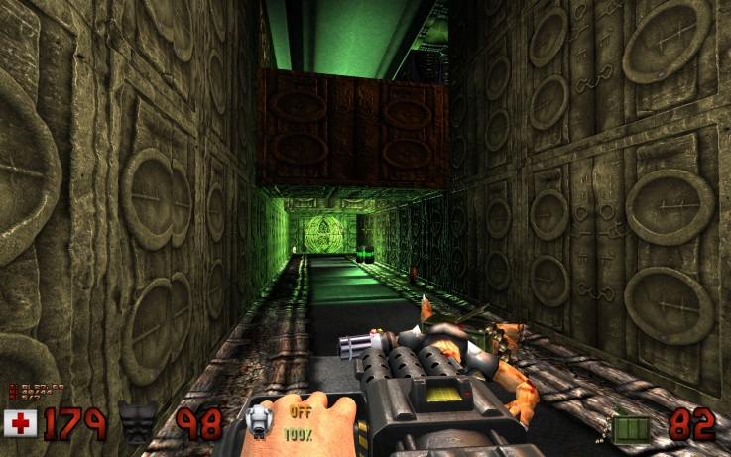
Fig. 12. Duke Nukem. Game play image [9].
Some of the responses indicate that, if set in the correct setting, a designer could invoke a sense of mysticism. That association might be harder to achieve due to the results indicating a strong sense of caution, though given the correct environment one could achieve this response. An example comes from a German game called Trine 2 seen in Fig.13. below.

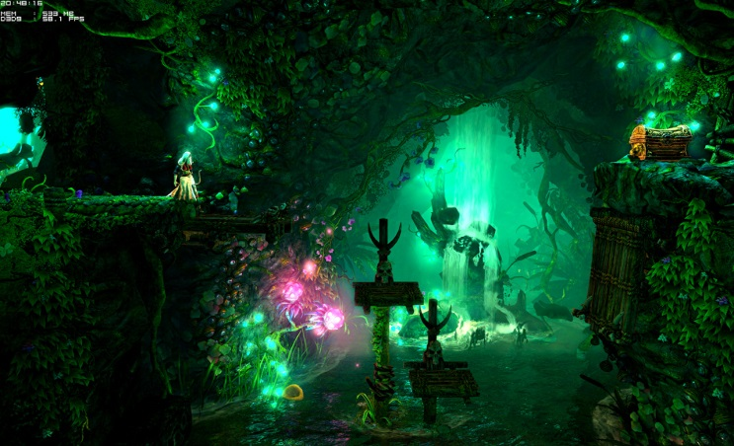
Fig. 13. Trine 2. Gameplay Image [10].
Purple is another color that would have to carefully be displayed. With the previously mentioned dichotomy, purple could be strongly used to set a sense of mystical power, luring a player in to gain a magical power. Alternatively, purple could be used to create a sense of caution, using it as lighting to warn players that a false move could end badly for them due to a sense of the unknown. As seen in Fig.14, a screen shot of Diablo 3, displaying the player having to battle demonic forces.

Fig. 14. Diablo 3. Gameplay image [8].
There are several ways in which this work could be extended. First, participants seemed to vary in the intensity of their response to certain colors, so work investigation a means to identify which colors will evoke stronger reactions from a given individual could be very beneficial. Second, participants could be tested on a variety of colored lighting and not just two, though this would require a variety of environments to keep participants engaged.
Another possible change that could have been made to the process would be to change the task given to the players, finding the wallet. One of the things observed and possibly influenced the results was the how curious the players were. Many players became obsessed in finding the wallet, some possibly frustrated or becoming even more curious as to where it could be when they failed to do so after only a couple of minutes, or there first pass through.
Lastly, some things that could have be tested or added would have been to test different lighting compositions to see if the way something was lit affected players as well as color or the combination of such. The three main lighting compositions would have been the basics, up lighting, to light something from under it, down lighting, to light something from above, and realistic lighting, which is what was used.
The predictions of this thesis treaded on broad grounds of emotional associations. However, light was shed on these colors that are rarely seen in gaming environments, and the surface of this new language is emerging.

References
- F. Birren, “Color Psychology and Color Therapy,” 2ndEd, New York, 1961.
- A. Kargere, “Color and personality,” Saphrograph Company, New York.
- Stephen J. Sidelinger, Color Manual, Prentice-Hall, Inc, Englewood Cliffs, New Jersey, 1985.
- “Color theory”, Wikipedia.com
- “Color Wheel.” www.interiordesignipedia.com/color-wheel.html
- “Color Schemes” http://www.darlingdoodlesdesign.com/wp-content/uploads/2013/02/Color-Schemes.jpg
- “What your logo’s say about your company(infographic)”, Rachel Gillet, fastcompany.com
- Diablo 3, Blizzard.
- Fig 12. Duke nukem, ID Software.
- Fig. 13. Trine 2, Frozenbyte.

